# Assignment 1-B

We have to fit various regression models to a dataset containing 546 samples, where the $n$-th sample is of the form:

$$\left(x_{n_{1}},x_{n_{2}},y_{n}\right)$$

where $\left(x_{n_{1}},x_{n_{2}}\right)$ are the features and $y_{n}$ is the target value.

We create a 80-20 split of the dataset for training and testing respectively.

### Structure of matrices

Our feature matrix is stored as:

$$X={\left(\begin{matrix}x_{1_{1}} & x_{2_{1}} & … & x_{N_{1}} \\ x_{1_{2}} & x_{2_{2}} & … & x_{N_{2}}\end{matrix}\right)}_{2×N}$$

and the target vector is stored as:

$$Y={\left(\begin{matrix}y_{1} & y_{2} & … & y_{N}\end{matrix}\right)}_{1×N}$$

# POLYNOMIAL REGRESSION

### Our model

$$f_{\text{w}}\left({\text{x}}_{i}\right)=\sum_{j=0}^{M}{w_{j}}x_{i_{j}}$$

where $x_{i_{0}}=1$ for all training examples, $x_{i_{1}}$ and $x_{i_{2}}$ correspond to the features in dataset and the remaining $x_{i_{j}}$’s refer to higher degree terms found by multiplying $x_{i_{1}}$ and $x_{i_{2}}$.

### Normalization

We calculate the mean ($μ$) and standard deviation ($σ$) of the training data. We normalize training data as:

$$x_{i_{j}}=\frac{x_{i_{j}}−μ_{j}}{σ_{j}}$$

We also store $μ$ and $σ$ vectors to normalize the testing data using the same $μ$ and $σ$.

### Generating Feature Matrix

We generate feature matrix for polynomial regression using nested for loops. We generate a matrix with all the polynomial features till degree 9, and later slice rows from this matrix to run polynomial regression for lower degrees.

Our generated feature matrix is as follows:

$$\left(\begin{matrix}1 & 1 & … & 1 \\ x_{1_{1}} & x_{2_{1}} & … & x_{N_{1}} \\ x_{1_{2}} & x_{2_{2}} & … & x_{N_{2}} \\ {\left(x_{1_{1}}\right)}^{2} & {\left(x_{2_{1}}\right)}^{2} & … & {\left(x_{N_{1}}\right)}^{2} \\ \left(x_{1_{1}}\right)\left(x_{1_{2}}\right) & \left(x_{1_{2}}\right)\left(x_{2_{2}}\right) & … & \left(x_{N_{1}}\right)\left(x_{N_{2}}\right) \\ {\left(x_{1_{2}}\right)}^{2} & {\left(x_{2_{2}}\right)}^{2} & … & {\left(x_{N_{2}}\right)}^{2} \\ ⋮ & ⋮ & & ⋮ \\ {\left(x_{1_{2}}\right)}^{9} & {\left(x_{2_{2}}\right)}^{9} & … & {\left(x_{N_{2}}\right)}^{9}\end{matrix}\right)$$

### Cost Function

We calculate cost function for regression as follows:

$$\begin{matrix} & J\left(\text{w}\right)=\frac{1}{2}\sum_{i=1}^{N}{{\left(y_{i}−f_{\text{w}}\left({\text{x}}_{i}\right)\right)}^{2}} \\ \\ & J\left(\text{w}\right)=\frac{1}{2} \left(\text{Y}−{\text{W}}^{T} \text{X}\right) {\left(\text{Y}−{\text{W}}^{T} \text{X}\right)}^{T}\end{matrix}$$

### Error Function

The error function will be the $RMS$ of the difference between the predicted value and the given value

$$\begin{matrix} & E\left(\text{w}\right)=\sqrt{\frac{1}{N} \sum_{i=1}^{N}{ }{\left(y_{i}−f_{\text{w}}\left({\text{x}}_{i}\right)\right)}^{2}} \\ \\ & E\left(\text{w}\right)=\sqrt{\frac{1}{N} \left(\text{Y}−{\text{W}}^{T} \text{X}\right) {\left(\text{Y}−{\text{W}}^{T} \text{X}\right)}^{T}}\end{matrix}$$

### Gradient Descent

We implement gradient descent by updating the weights for a fixed number of iterations:

$$w_{j}=w_{j}−α\frac{∂J\left(\text{w}\right)}{∂w_{j}}$$

where $α$ is the learning rate, and

$$\frac{∂J\left(\text{w}\right)}{∂w_{j}}=\sum_{i=1}^{N}{\left(y_{i}−f_{\text{w}}\left({\text{x}}_{i}\right)\right)}\left(−x_{i_{j}}\right)$$

Which in matrix form will be

$$ $$

### Stochastic Gradient Descent

We implement stochastic gradient descent similarly, the cost and its gradient is calculated with respect to a randomly chosed sample (instead of all samples) on every iteration.

$$w_{j}=w_{j}−α \frac{∂J_{SGD}\left(\text{w}\right)}{∂w_{j}}$$

Cost function for SGD:

$$$$

Gradient of cost function for SGD:

$$\frac{∂J_{SGD}\left(\text{w}\right)}{∂w_{j}}=\left(y_{i}−f_{\text{w}}\left({\text{x}}_{i}\right)\right)\left(−x_{i_{j}}\right)$$

$$\frac{d}{dw}J_{SGD}\left(\text{w}\right)=\left(−{\text{x}}_{i}\right)\left(y_{i}−{\text{w}}^{T} {\text{x}}_{i}\right)$$

Finally Stochastic Gradient Descent looks like -

$$\text{w}=\text{w}−α \left(−{\text{x}}_{i}\right)\left(y_{i}−{\text{w}}^{T} {\text{x}}_{i}\right)$$

$i$ is chosen randomly from $\left(1,N\right)$ for every iteration.

### Regression

The $training_polynomial_regression\left(\right)$ function takes three parameters $−$

$ Y $ $−$ The target attribute matrix

$ X $ $−$ The complete feature matrix

$ descent_type $ $−$ Specifies wether gradient descent or stochastic gradient descent has to be performed

The function, iterates through degrees $0$ to $9$ and finds the weights $\left(W\right)$ by performing the appropriate descent on the given data.

The errors through each iteration is stored in $cost_desc$ which is then plotted. The final errors for each degree is stored in $error_history$

The final weights for each degree is stored in $W_history$ which is returned along with $error_history$

##### Getting the feature matrix for degree $d$

The feature matrix passed to the function, contains features upto degree $9$. The feature matrix is created in such a way that the first $\left({d+2 \atop 2}\right)$ rows of $X$, give the feature matrix for degree $d$

### Testing

The funcion $testing_polynomial_regression\left(\right)$ takes $3$ arguments $−$

$Y$ $−$ The target attribute for the testing data

$X$ $−$ The complete feature matrix of the testing data

$W$ $−$ A $2$-d array. The $i^{th}$ row of which stores the weights for degree $i$

The final testing error of each degree is stored in $error_history$ which is then returned by the function.

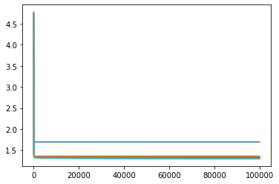 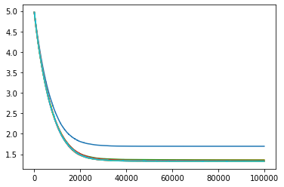 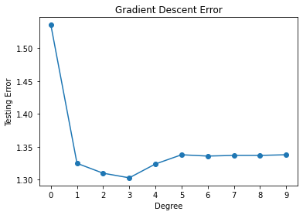 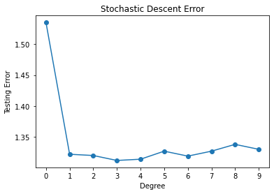

| Degree | Training Error (Gradient) | Training Error (Stochastic) | Testing Error (Gradient) | Testing Error (Stochastic) |
| --- | --- | --- | --- | --- |
| 0 | 1.6944 | 1.6944 | 1.534838 | 1.534624 |
| 1 | 1.3606 | 1.3608 | 1.324867 | 1.323926 |
| 2 | 1.3325 | 1.3570 | 1.309989 | 1.318076 |
| 3 | 1.3269 | 1.3370 | 1.303107 | 1.309406 |
| 4 | 1.3187 | 1.3306 | 1.323781 | 1.316062 |
| 5 | 1.3101 | 1.3302 | 1.338475 | 1.325186 |
| 6 | 1.3055 | 1.3295 | 1.336455 | 1.323378 |
| 7 | 1.3022 | 1.3291 | 1.337395 | 1.330144 |
| 8 | 1.2991 | 1.3280 | 1.337464 | 1.334542 |
| 9 | 1.2970 | 1.3271 | 1.338169 | 1.335491 |

Since the testing error is the least for degree 3, we can conclude that polynomial regression of degree 3 best fits the given dataset.

# REGULARIZATION

### Regularized Cost Function

We calculate cost function for regularized linear regression as follows:

$$J_{reg}\left(\text{w}\right)=\frac{1}{2}\sum_{i=1}^{N}{{\left(y_{i}−f_{\text{w}}\left({\text{x}}_{i}\right)\right)}^{2}}+\frac{λ}{2}\sum_{j=1}^{M}{{\left|w_{j}\right|}^{q}}$$

$$J_{reg}\left(\text{w}\right)=\frac{1}{2}\left(Y−W^{T}X\right){\left(Y−W^{T}X\right)}^{T}+\frac{λ}{2}\sum_{j=1}^{M}{{\left|w_{j}\right|}^{q}}$$

The bias, $w_{0}$ is not regularized.

### Regularized Linear Regression

We implement regularized linear regression by updating the weights for a fixed number of iterations:

$$w_{j}=w_{j}−α\frac{∂J_{reg}\left(\text{w}\right)}{∂w_{j}}$$

where $α$ is the learning rate, and

$$\frac{∂J_{reg}\left(\text{w}\right)}{∂w_{j}}=\sum_{i=1}^{N}{\left(y_{i}−f_{\text{w}}\left({\text{x}}_{i}\right)\right)}\left(−x_{i_{j}}\right)+\frac{λ}{2}q{\left|w_{j}\right|}^{q−1}\frac{w_{j}}{\left|w_{j}\right|}$$

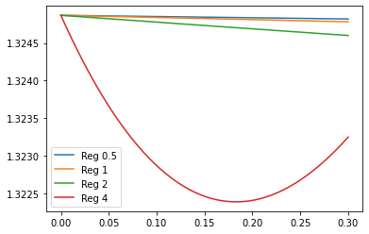

regularization

| Type | Training RMS | Testing RMS |
| --- | --- | --- |
| Unregularized Linear | 1.360600 | 1.324867 |
| Unregularized Cubic | 1.326900 | 1.303107 |
| Regularized 0.5 | 1.375088 | 1.307830 |
| Regularized 1 | 1.375890 | 1.308257 |
| Regularized 2 | 1.365160 | 1.320221 |
| Regularized 4 | 1.362957 | 1.322391 |

##### Comparison between the best regularized and the best non-regularized model

Of all the regularized models, the one where q is 0.5 performs the best in testing data. Comparing this with the best performing non-regularized polynomial regression model (cubic regression) we can see that cubic regression performs better.

This can be explained as non-regularized linear regression does not overfit the training dataset hence adding regularization does not improve the performance of the model significantly.

# Surface plots of regression models

